Sceptre 1080p Nvidia Config

Nvidia Control Panel

Adjust desktop color settings

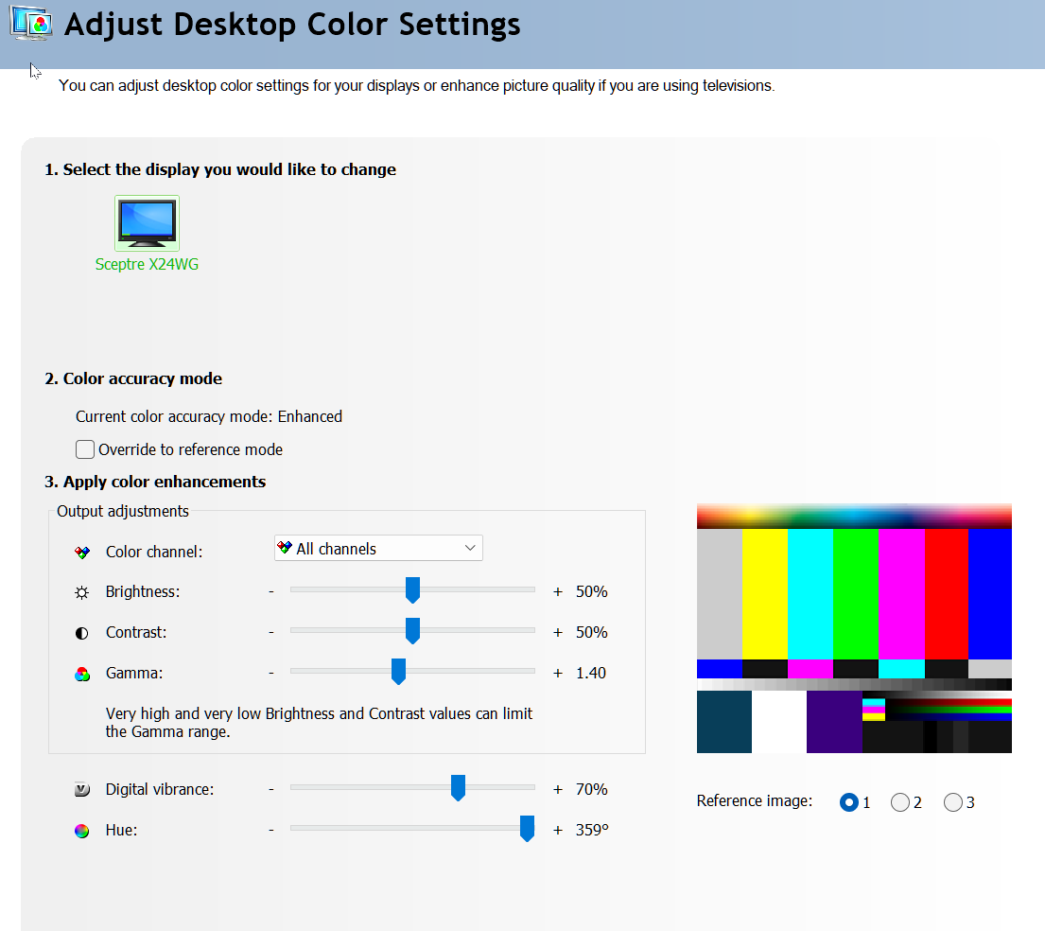
Manage 3D settings

Global Settings
Shader Cache Size – 100GB

Program Settings – Squandron 42 – Star Citizen (starcitizen.exe)
Low Latency Mode – Ultra
Power management mode – Prefer maximum performance
Texture filtering – Quality – High performance
Text filtering – Negative LOD bias – Clamp
Thread optimization – On
Vertical sync – Off (or fast)

